COMPUTER NETWORKS LAB

REPORT ASSIGNMENT-5

NAME: SOHAM LAHIRI

CLASS: BCSE UG-III 5TH SEMESTER

ROLL NO: 002210501107

GROUP: A3

SUBMISSION DATE: 18/11/2024

Problem Statement:
1.Generate some ICMP traffic by using the Ping command line tool to check the connectivity of a neighbouring machine (or router). Note the results in Wireshark. The initial ARP request broadcast from your PC determines the physical MAC address of the network IP Address, and the ARP reply from the neighboring system. After the ARP request, the pings (ICMP echo request and replies) can be seen.

Outputs:
Command Prompt:
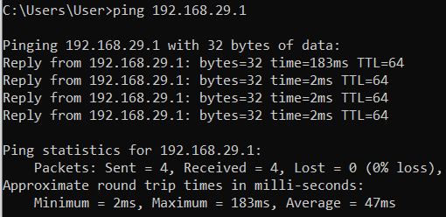

Wireshark:
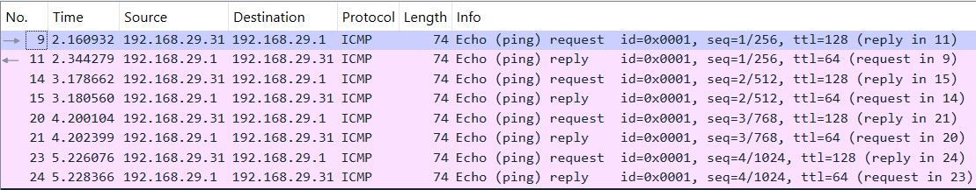

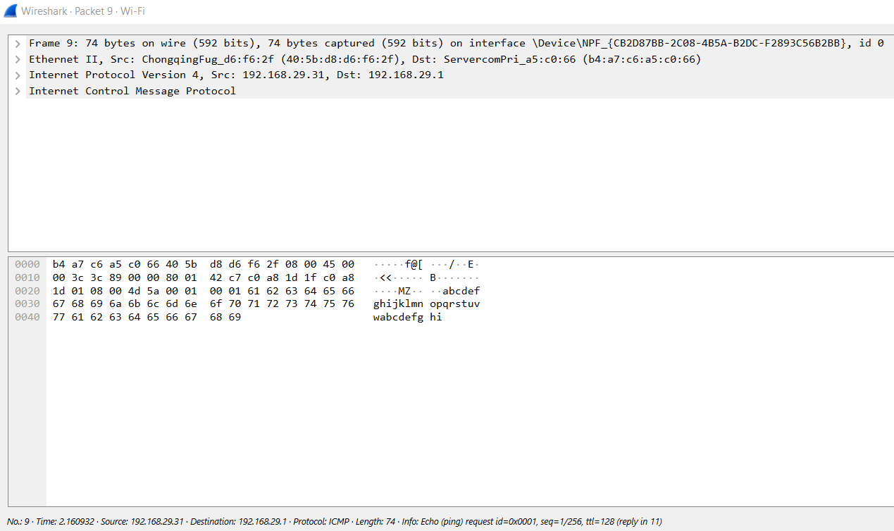
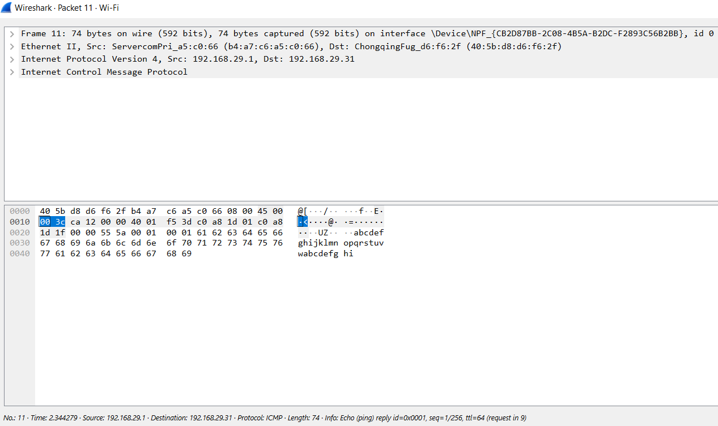

2. Generate some web traffic and
a. find the list of the different protocols that appear in the protocol column in the unfiltered packet-listing window of Wireshark.
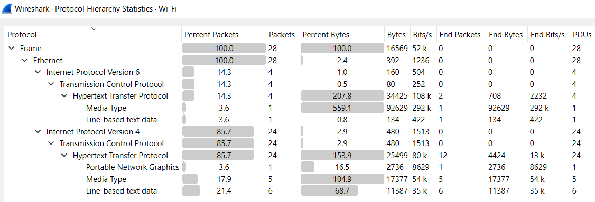

b. How long did it take from when the HTTP GET message was sent until the HTTP OK reply was received? (By default, the value of the Time column in the packet-listing window is the amount of time, in seconds, since Wireshark tracing began. To display the Time field in time-of-day format, select the Wireshark View pull down menu, then select Time Display Format, then select Time-of-day.)
According to the Time column in above snapshot, it took 0.264241seconds approx. to get the HTTP response.

c. What is the Internet address of the website? What is the Internet address of your computer?
The local IP is 192.168.29.31 and the server IP is 44.228.249.3 .

d. Search back through your capture, and find an HTTP packet containing a GET command. Click on the packet in the Packet List Panel. Then expand the HTTP layer in the Packet Details Panel, from the packet.
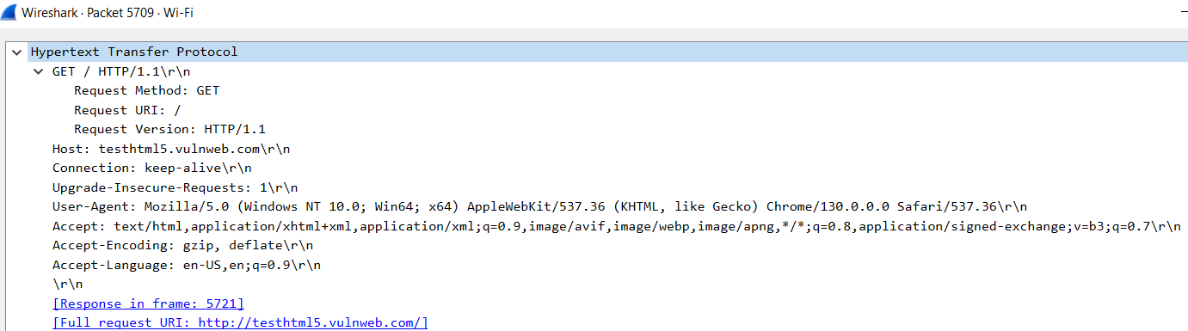
e. Find out the value of the Host from the Packet Details Panel, within the GET command.

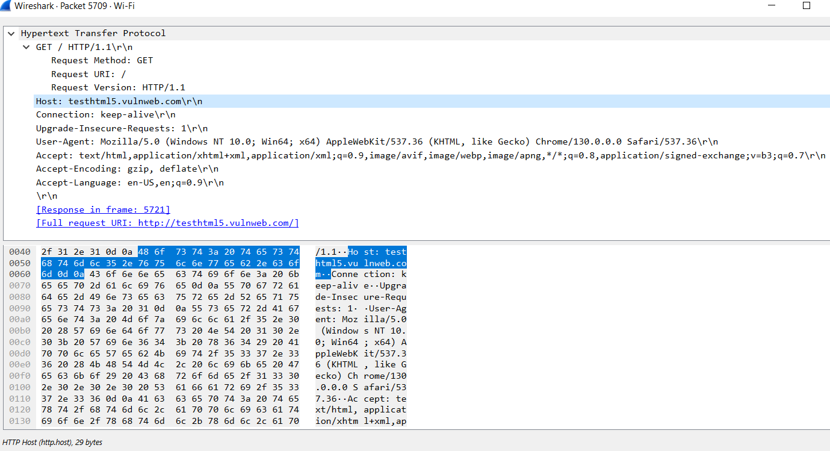
The value of Host as shown above is: testhtml5.vulnweb.com .

3. Highlight the Hex and ASCII representations of the packet in the Packet Bytes Panel.
(Highlighted in blue)

4. Find out the first 4 bytes of the Hex value of the Host parameter from the Packet Bytes Panel.
From the previous snippet, the first 4 bytes of the Hex value of the Host parameter from the Packet Bytes Panel are: 48 6f 73 74

5. Filter packets with http, TCP, DNS and other protocols.
a. Find out what those packets contain by following one of the conversations (also called network flows), select one of the packets and press the right mouse button..click on follow.
Filtered by HTTP:
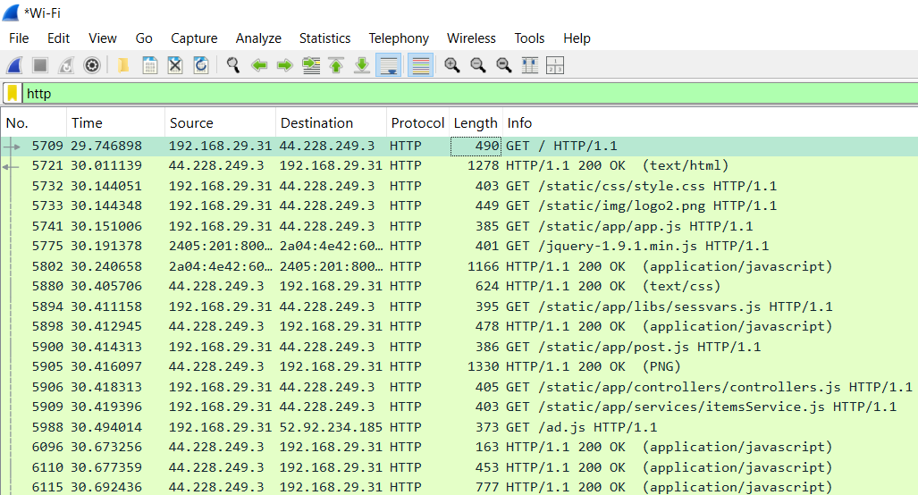

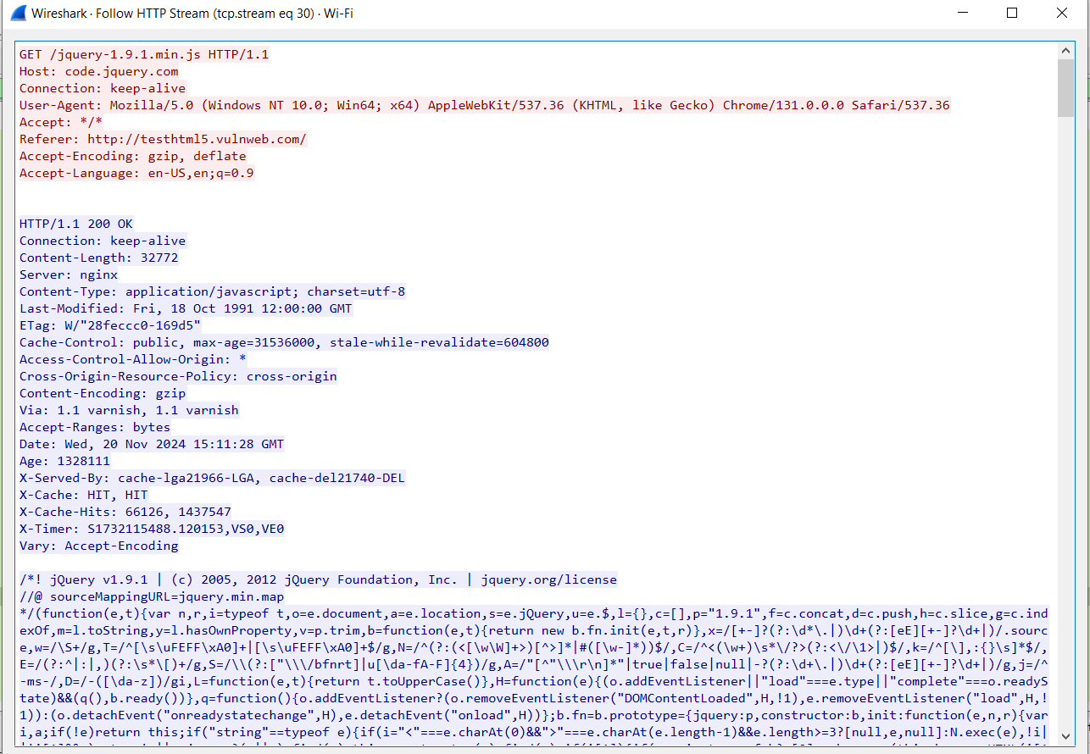

Following a HTTP Packet

Filtered by TCP:
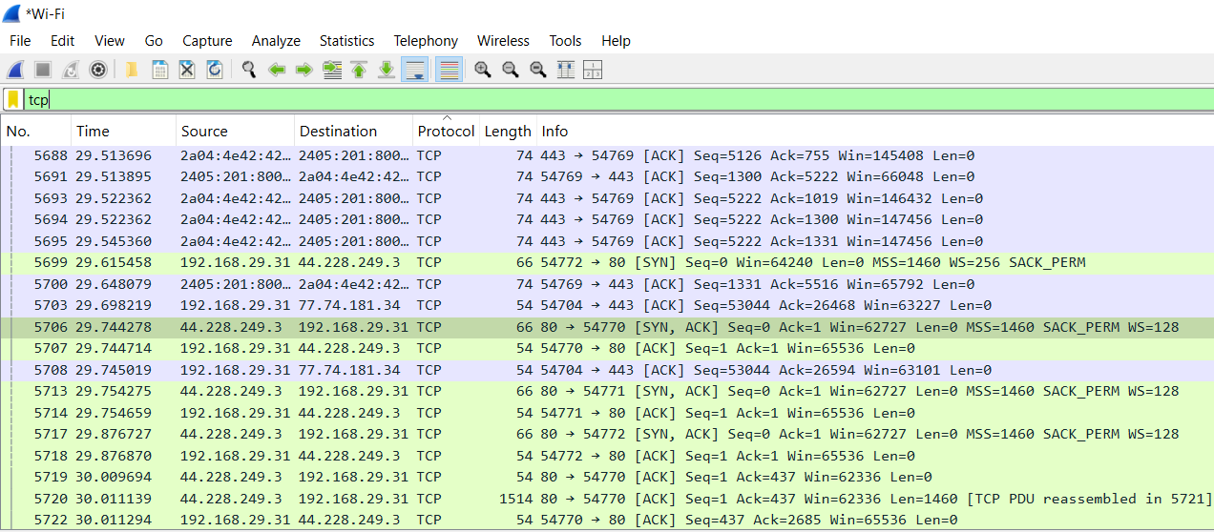

Filtered by DNS:
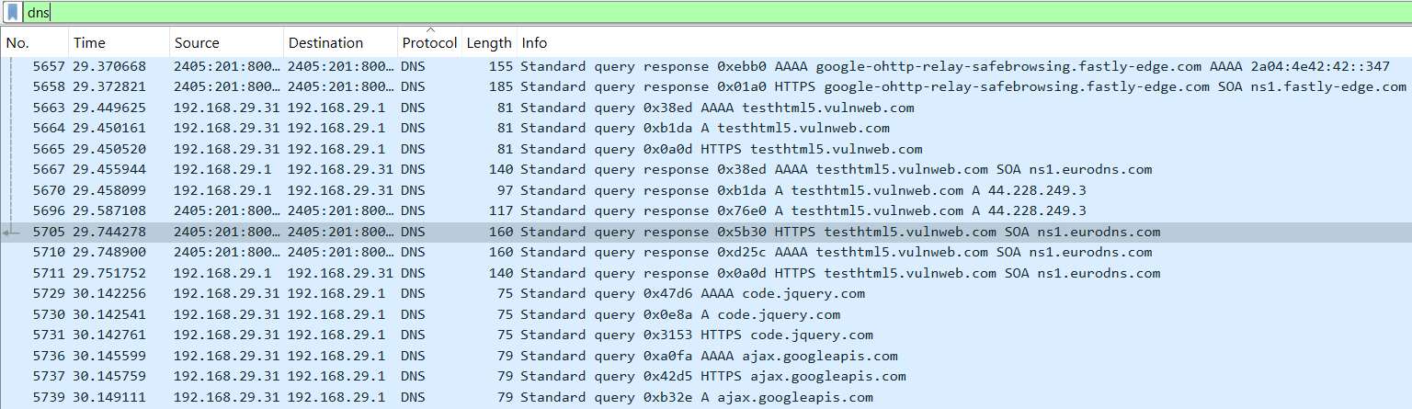

Filtered by TLS:
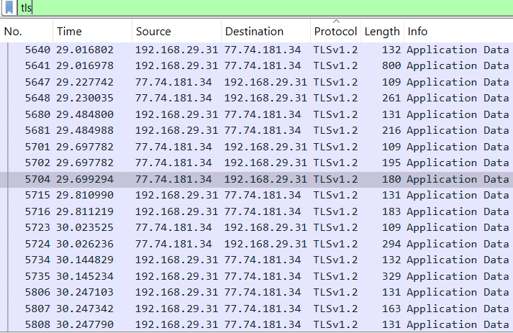

6. Search through your capture, and find an HTTP packet coming back from the server (TCP Source Port == 80). Expand the Ethernet layer in the Packet Details Panel.
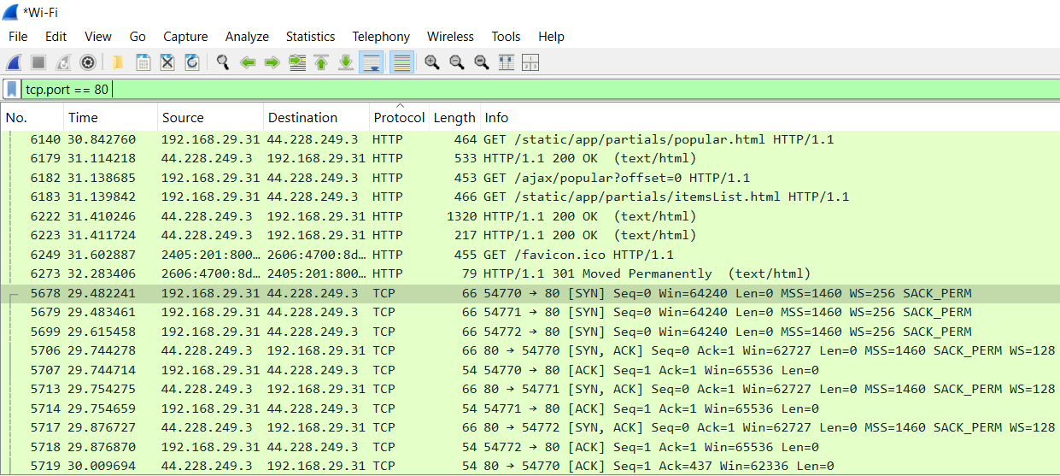

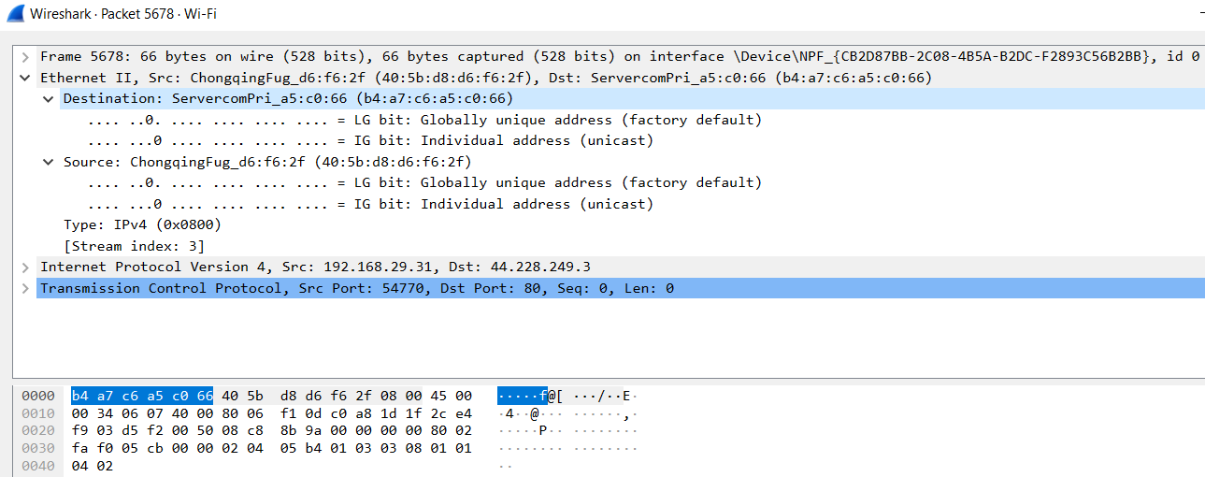

7. What are the manufacturers of your PC’s Network Interface Card (NIC), and the servers NIC?
So according to the details, my PC’s Network Interface Card (NIC) has the manufacturer: ServercomPri.
And the server’s Network Interface Card (NIC) has the manufacturer: ChongqingFug.

8. What are the Hex values (shown in the raw bytes panel) of the two NICS Manufacturers OUIs?
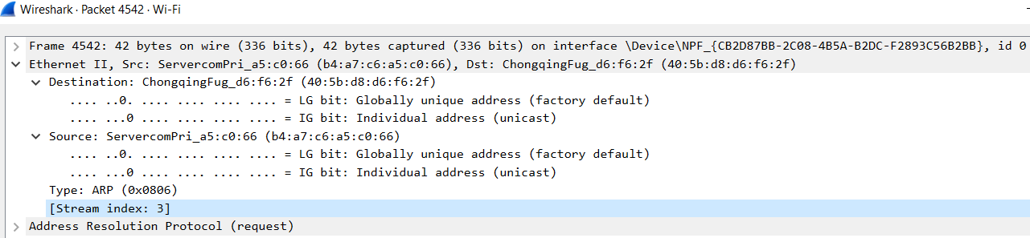
Ans: The hex values (shown the raw bytes panel) of the two NICS Manufacturers OUIs are: b4:a7:c6:a5:c0:66 (my NIC raw bytes) and 40:5b:d8:d6:f6:2f (server NIC).

9. Find the following statistics:
a. What percentage of packets in your capture are TCP, and give an example of the higher level protocol which uses TCP?
b. What percentage of packets in your capture are UDP, and give an example of the higher level protocol which uses UDP?

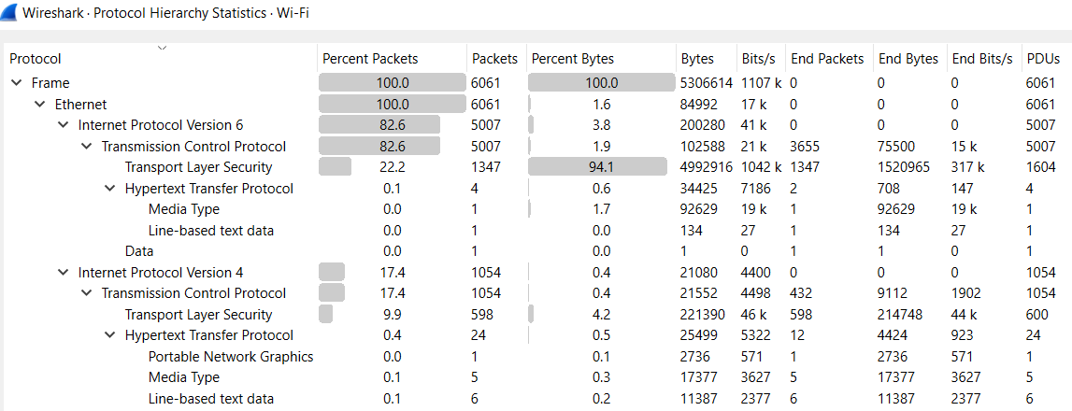
From the above statistics, the percentage of TCP packets(in IPV6) is 82.6%. A protocol that uses TCP is HTTP.
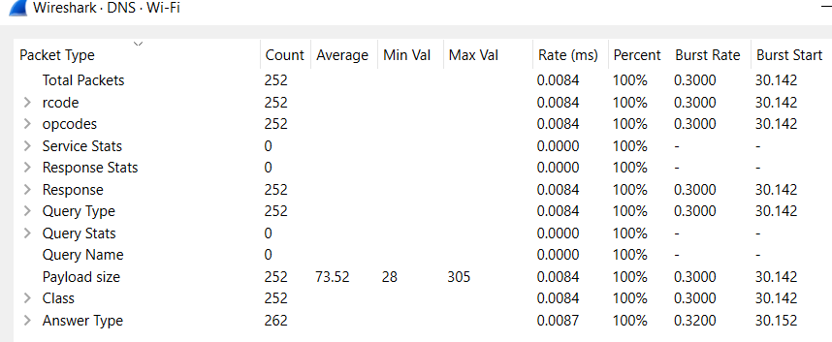
A protocol that uses UDP is DNS.

10. Find the traffic flow Select the Statistics->Flow Graph menu option. Choose General Flow and
Network Source options, and click the OK button.

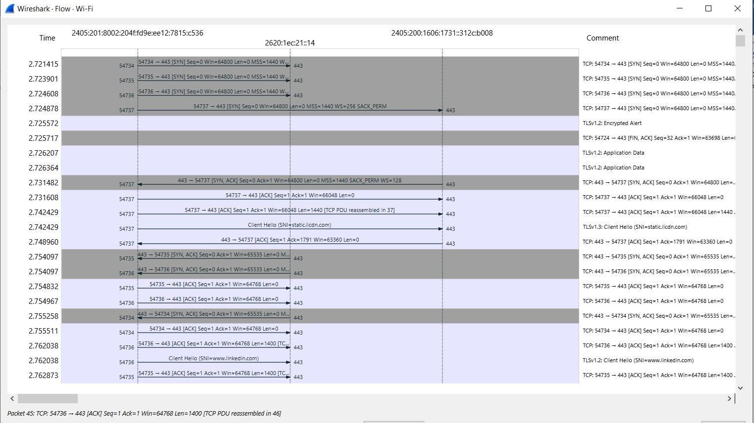

COMMENTS:

This assignment has significantly enhanced my understanding of network traffic analysis using Wireshark. By generating and capturing ICMP traffic, I observed the ARP resolution process and analyzed how ICMP echo requests and replies are exchanged. Additionally, by generating web traffic, I explored various protocols, such as HTTP, TCP, and DNS, and learned how to measure the time between HTTP GET requests and HTTP OK replies. The exercise of filtering packets, analyzing network flows, and examining packet bytes deepened my knowledge of how different protocols interact at the packet level. Moreover, I gained practical insights into identifying NIC manufacturers and analyzing traffic statistics, including the percentage of TCP and UDP packets. This hands-on experience has been invaluable in improving my understanding of network communication and protocol analysis. I am grateful to my teacher for their guidance throughout the assignment, which has greatly contributed to my learning.

